Practice 3 rollno:2520030022 name:AVSNRAkhila
STEP 1: CREATE ORDERS TABLE
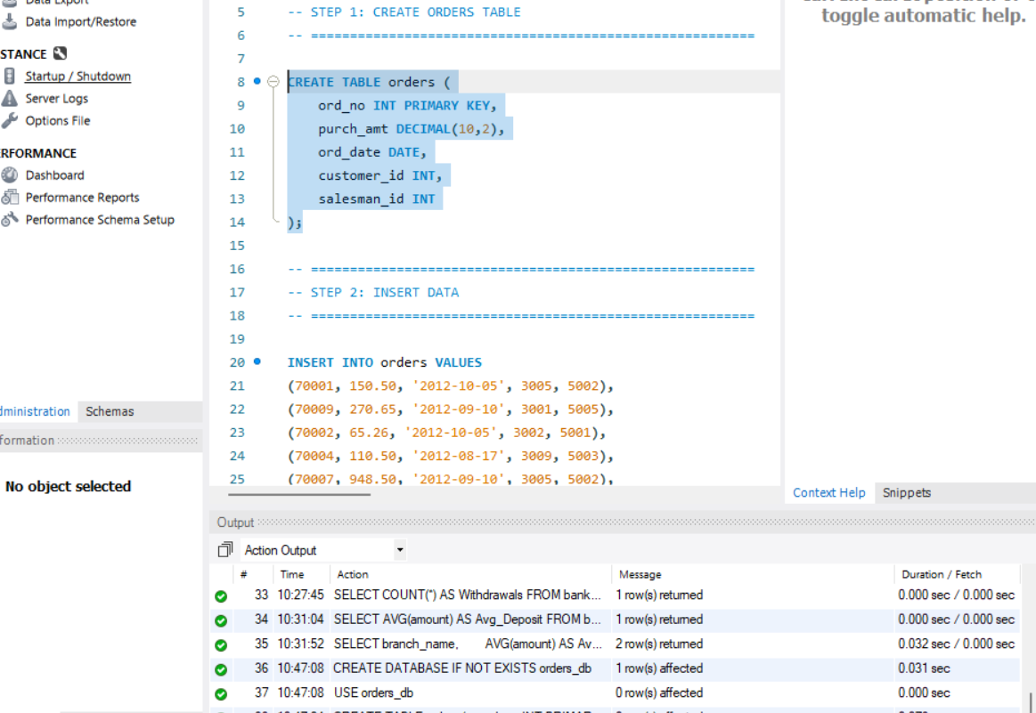
STEP 2: INSERT DATA
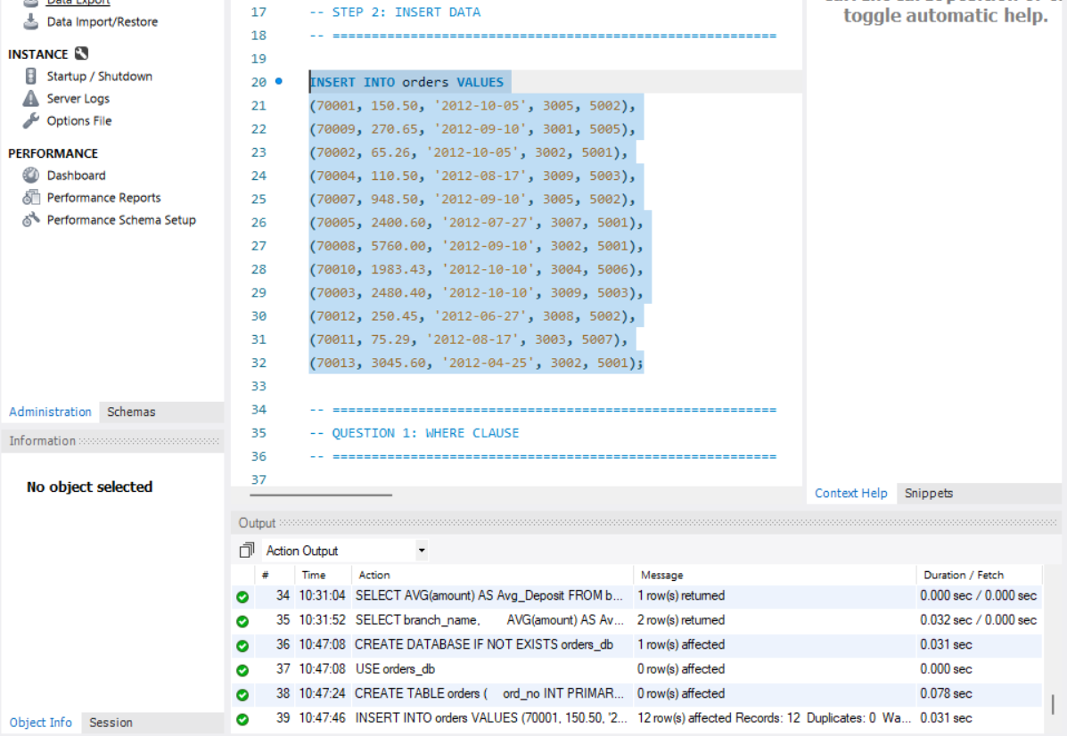
QUESTION 1: WHERE CLAUSE
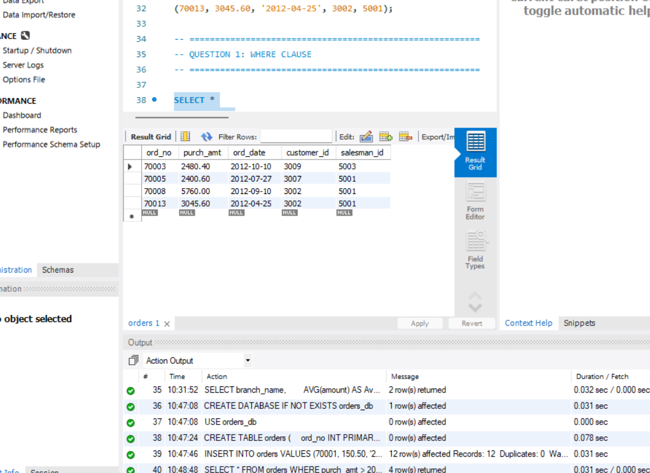
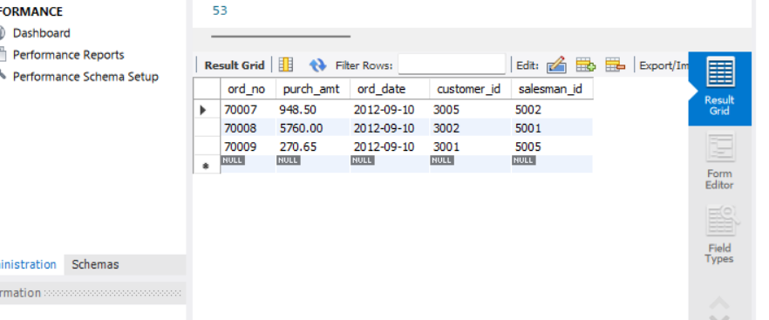

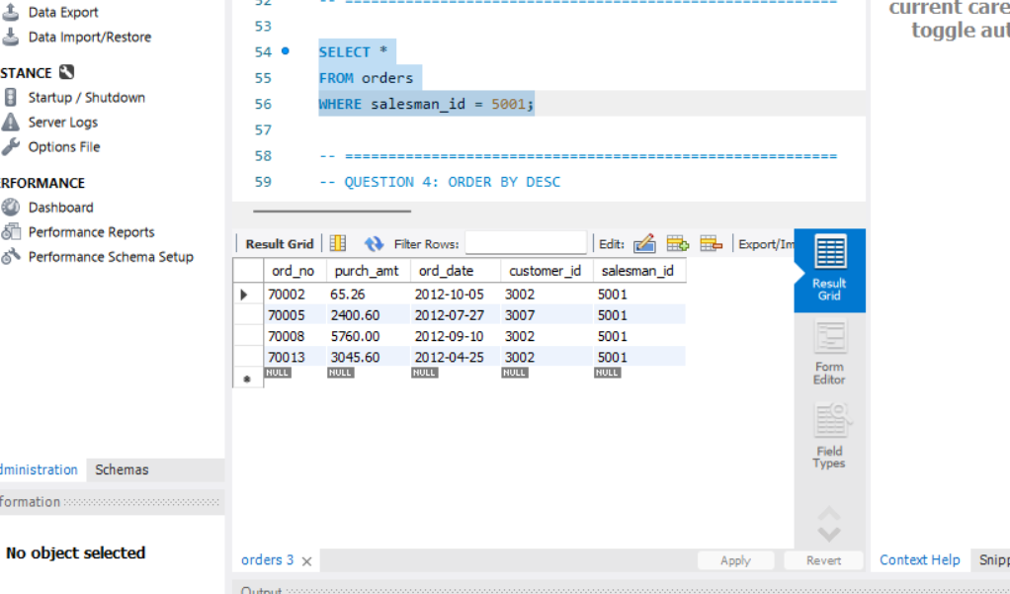
QUESTION 4: ORDER BY DESC
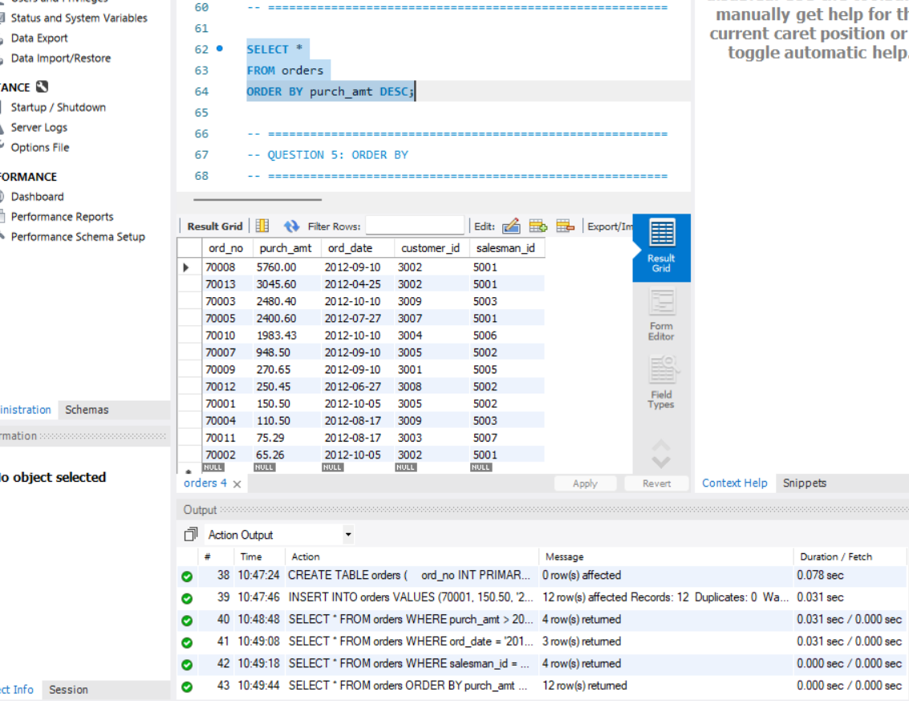
QUESTION 5: ORDER BY
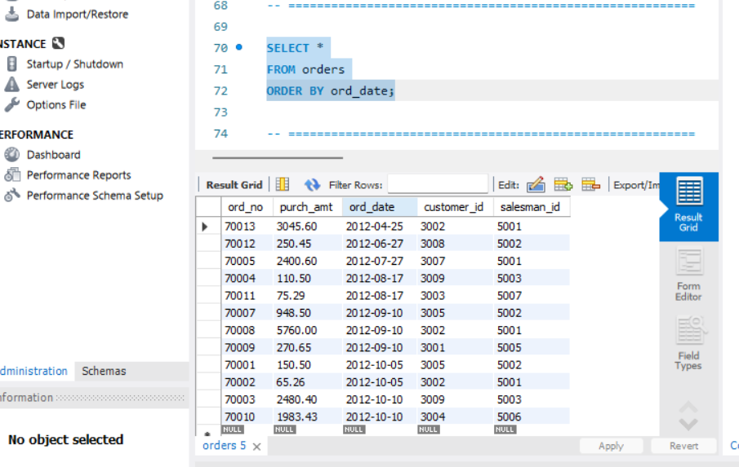
QUESTION 6: SUM()
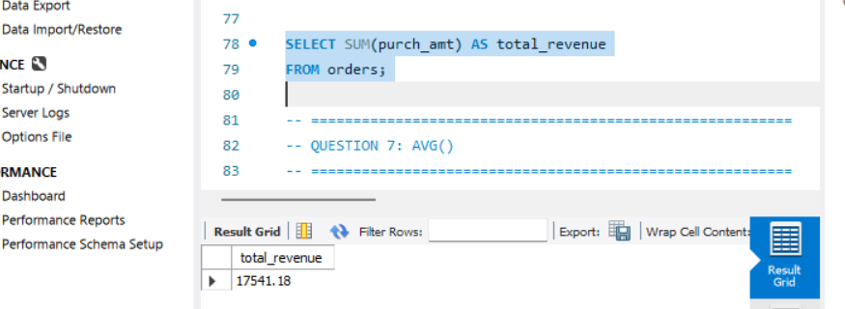
QUESTION 7: AVG()
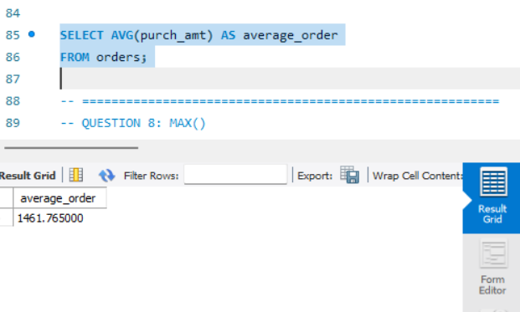
QUESTION 8: MAX()
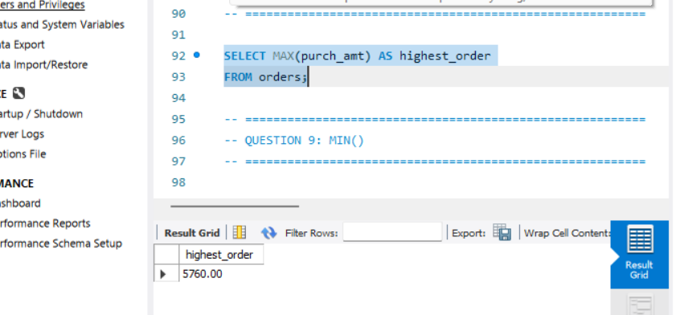
QUESTION 9: MIN()
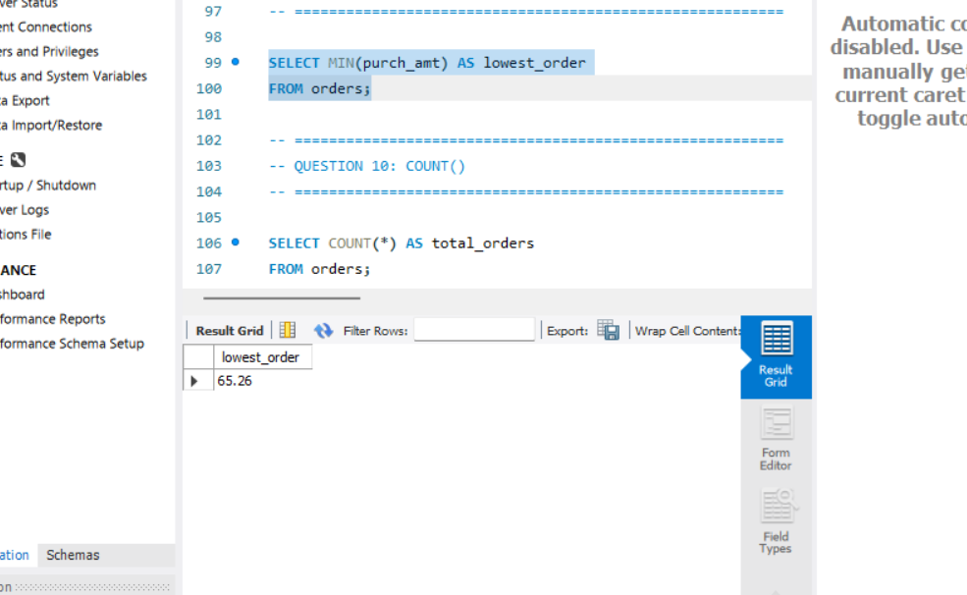
QUESTION 10: COUNT()
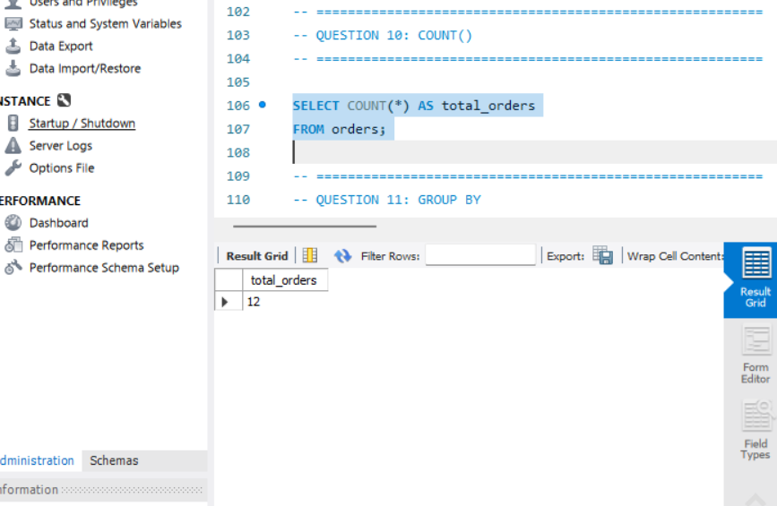
QUESTION 11: GROUP BY
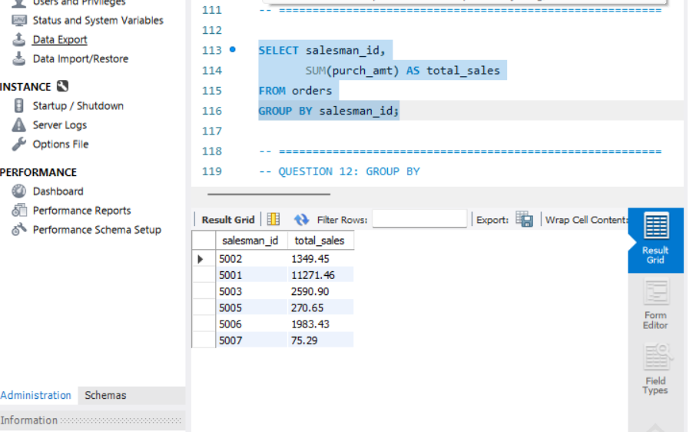
QUESTION 12: GROUP BY
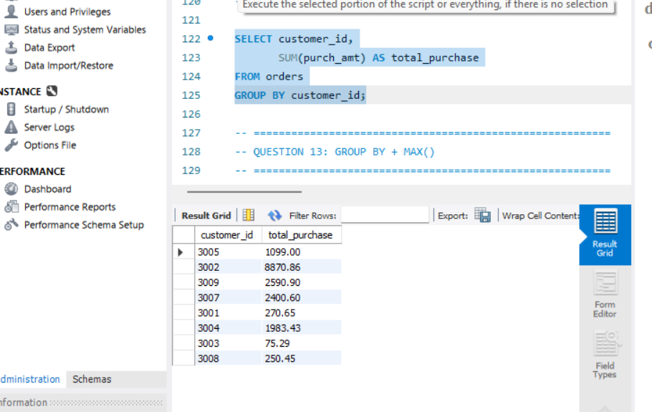
QUESTION 13: GROUP BY + MAX()
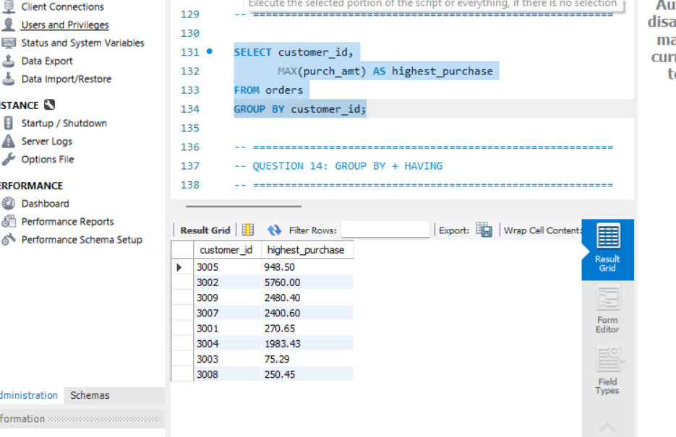
QUESTION 14: GROUP BY + HAVING
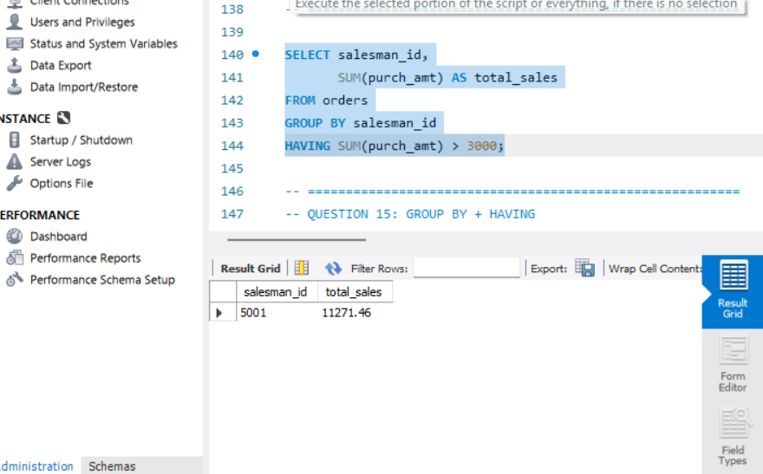
QUESTION 15: GROUP BY + HAVING
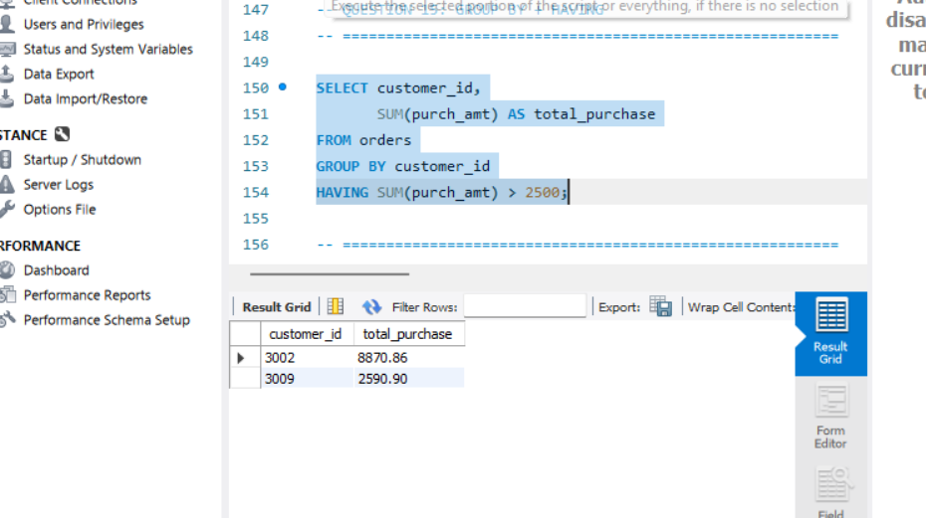
QUESTION 16: GROUP BY + HAVING
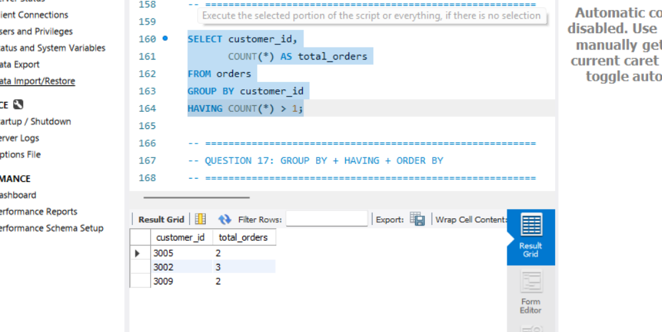
QUESTION 17: GROUP BY + HAVING + ORDER BY
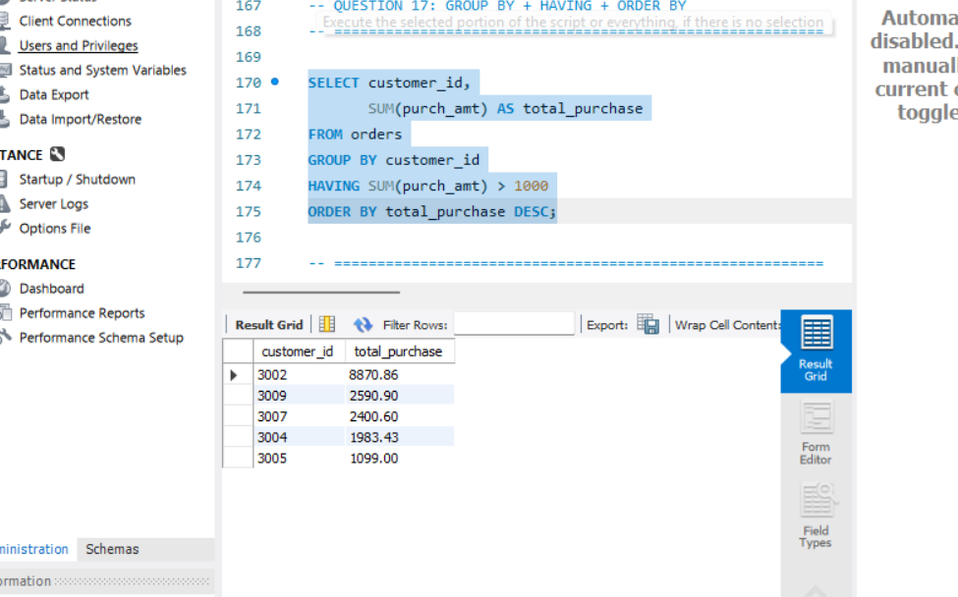
QUESTION 18: BETWEEN + HAVING
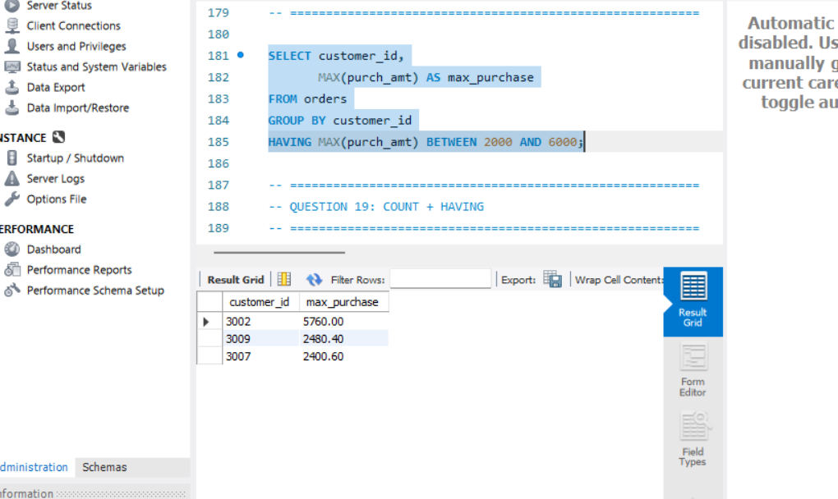
QUESTION 19: COUNT + HAVING
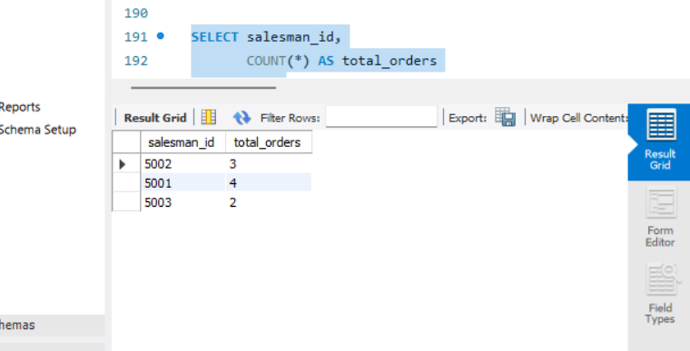
QUESTION 20: MAX + GROUP BY + HAVING
